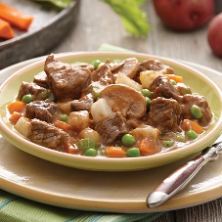 

A Recipe For:

# Beef and Vegetable Soup

**From the Kitchen of:** Mom

**Servings:** 8

**Prep Time: 25** minutes **Bake Time:** 7 hours **Bake Temp:**

**Ingredients:**

* 2 Tbsp butter
* 1 ½ lbs beef stew meat, cut into cubes
* 1 onion, chopped
* 2 cloves garlic, minced
* 6 cups low-sodium beef stock
* 1 cup green beans, cut into 1-inch pieces
* 1 cup diced zucchini
* 1 cup diced cauliflower
* 2 Tbsp minced basil leaves
* ½ tsp minced thyme leaves

**Instructions:**

1. Set a large skillet over medium-high heat and melt the butter.
2. Add the beef in a single layer (work in baches to avoid crowding the skillet, if needed) and cook until the beef is browned, about 8 minutes.
3. Transfer the beef to the slow cooker.
4. Add the onions to the skillet and cook until they have softened, about 10 minutes. Add the garlic and cook until fragrant, another minute.
5. Transfer the onions and any rendered beef at to the slow cooker.
6. Add the beef stock to the slow cooker, set the heat to high and cook until the beef is very tender, about 6 hours. Add the green beans, zucchini and cauliflower and cook until the vegetables are tender, about 30-45 minutes more. Just before serving, stir in the basil and thyme.